LAHORE COLLEGE FOR WOMEN UNIVERSITY
Jail Road, Lahore – Pakistan. Tel: 042-9203072,9203089, 9201950 Fax: 042-9203077

DEPARTMENT OF ELECTRICAL ENGINEERING
COURSE NAME: Wireless & Mobile Communication | TERM: Final | ASSIGNMENT #2
COURSE CODE: EE-414 | SEMESTER: VIII | GIVEN DATE: 15-04-2020  SUBMISSION DATE:15-05-2020
RESOURCE PERSON: Sajjad Rabbani | SESSION:2016-2020 | MAX. MARKS: 10

Sr. No. | Questions | CLO | PLO | Taxonomy Level | Marks
1 | a) If Pt=10W, Gt=10dB and L=1dB at 900 MHz compute the received power for the knife edge geometry shown below . Compare this value with the theoretical free space received power is an obstruction did not exist. What is the path loss due to diffraction for this case?  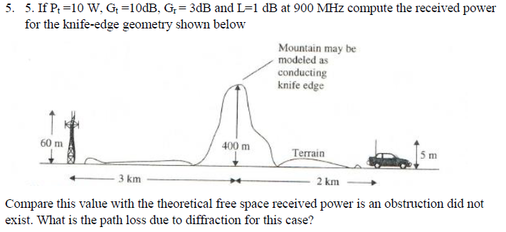  b) If the received power at a reference distance d0 = 1 km is equal to 1 microwatt, find the received powers at distances of 2 km, 5 km, 10 km, and 20 km from the same transmitter for the following path loss models: a. Free space; b. n = 3; c. n= 4; d. two-ray ground reflection using the exact expressions; and e. extended Hata model for a large city environment. Assume f=1800MHz, h_{t} =40m, h_{r} =3m. G_{t} = G_{r} = 0dB. Plot each of these models on the same graph over the range of 1km to 20km. Comment on the differences between these five models. | 2 | 2 | 4 | 5
2 | a) For the following digital wireless systems estimate the maximum rms delay spread for which no equalizer is required at the receiver (neglect channel coding, antenna diversity, or use of extremely low power levels).  b) Discuss the following  - Pseudo-Noise(PN sequence)  - QPSK Modulation Technique | 2 | 2 | 4 | 5

